|  |  |
| --- | --- |
|  | Project Specification |
|  |  |
| Generated 4/25/2015 | SMART Agile Tool |
|  |  |

Contents

Use Cases 2

SMART Agile Tool 2

Setup Project 4

UC-ProjectSetup1 - Create project 4

UC-ProjectSetup2 - Edit project Settings 4

UC-ProjectSetup3 - Create Team 4

UC-ProjectSetup4 - Delete team 4

UC-ProjectSetup5 - Edit Team 5

UC-ProjectSetup6 - Edit Team Member 5

UC-ProjectSetup7 - Add team member 5

UC-ProjectSetup8 - Edit Team Member 5

User Stories 7

Actors 8

Requirements 9

Definitions 10

Issues 11

# Use Cases

## SMART Agile Tool

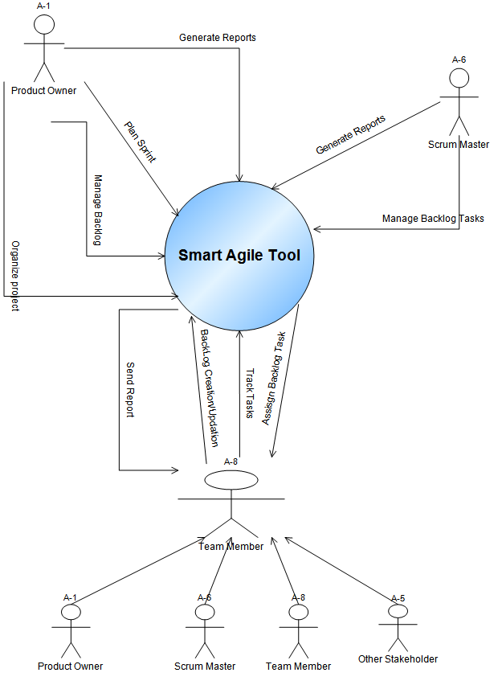

##### Context Diagram

## Setup Project

### UC-ProjectSetup1 - Create project

#### Main Success Scenario

#### Extensions

### UC-ProjectSetup2 - Edit project Settings

#### Main Success Scenario

#### Extensions

### UC-ProjectSetup3 - Create Team

#### Main Success Scenario

#### Extensions

### UC-ProjectSetup4 - Delete team

#### Main Success Scenario

#### Extensions

### UC-ProjectSetup5 - Edit Team

#### Main Success Scenario

#### Extensions

### UC-ProjectSetup6 - Edit Team Member

#### Main Success Scenario

#### Extensions

### UC-ProjectSetup7 - Add team member

#### Main Success Scenario

#### Extensions

### UC-ProjectSetup8 - Edit Team Member

#### Main Success Scenario

#### Extensions

# User Stories

# Actors

|  |  |  |
| --- | --- | --- |
| Name | Description | Participates in |
| Developer (A-3) |  |  |
| Other Stakeholder (A-5) |  |  |
| Product Owner (A-1) | Product Owner is the person responsible for a business initiative which could be customer driven requirement or a product initiative. He/She does following jobs:  1. manages High level Project Requirements ,  2. Creates user stories from High level Requirement.  3. Manages Project Backlog.  4. Prioritizes Work Items in Backlog. |  |
| Scrum Master (A-6) | Scrum Master Leads the Sprint Development Activity |  |
| Team Member (A-8) |  |  |
| Tester (A-4) |  |  |

# Requirements

# Definitions

|  |  |
| --- | --- |
|  |  |
| Backlog | List of all the Work Items identified for a project but not yet planned on a Sprint. |
| Report | Report can be Tabular Format or Control Charts. Following Type of Reports can be generated by the system  1. BurnDown Chart  2. Epic Progress Chart  3. Sprint Delivery Forecast |
| Requirement | Customer Requirement or a product feature |
| Sprint | Sprint is a fixed length iteration that consists of a set of Work Items. At the end of Sprint a Deliverable is released. |
| user stories | Requirements detailed out from User's point of view |
| Work Item | A Work Item is any actionable work that needs to be carried out to accomplish a task for a project sprint. It can be:  1. User story  2 A Bug  3. Software Architecture  4. Test Case Execeution |

# Issues